GEE-54883

DC - <SPIKE> Review updates needed for monthly contact deletion and new opt-ins of deleted "Inactive" contacts
Document Control 2
Definitions 2
Overview & Background 3
Overview 3
Acceptance Criteria 3
Current Automation 4
Recommended Pseudo Code 5
Set 1 6
Set 2 7
Set 3 10
Set 4 12
Set 5 19
Set 6 22
Set 7 23
Set 8 25

Document Control
Version Control
Version | Date | Changed By | E-mail | Change
1.0 | 6/17/2026 | David Mondrus | emondrus@kpmg.com | Creation

Definitions
Definitions/Acronyms (If Applicable)
Term | Definition
SFMC | Salesforce Marketing Cloud
DE | Data Extension (A Data Extension in Salesforce Marketing Cloud is a database table used to store and manage data)
SC | Sales Cloud
IFD | Individual Firm Details
CPE | Contact Point Email

Overview & Background

Overview
As the data management lead, I want to know what changes are necessary for our monthly contact deletion automation and how to address new opt-ins of deleted contacts, so that we can ensure these processes are aligned with changes made as a part of the one-time contact deletion in [GEE-53015] Identify and purge duplicate subscribers - Jira and allow email addresses to be removed from an auto-suppression list (if implemented).

Acceptance Criteria
BACKGROUND: Need recommendation for the following scenarios
SCENARIO 1: Monthly contact deletion automation
GIVEN a one-time contact deletion process has taken place (GEE-53015)
WHEN the ContactDelete_Combined runs
THEN it will perform contact deletion based on updated criteria:
- Does not have a channel // included in our monthly deletion process
- Contacts/Leads/Users no longer synchronized from Sales Cloud // included in our monthly deletion process
- Is a duplicate record in _Subscribers with email address as the subscriber key and is active // new criteria
- All Subscribers record for email address that has no SF ID record and is active // new criteria
- Email address not in the _Sent view last 6 months // new criteria

SCENARIO 2: New opt-ins of deleted contacts
GIVEN another one-time contact delete will take place of "inactive" (unsubscribed/held) contacts that meet the above criteria
AND this group of deleted inactive contacts will be added to an auto-suppression list
WHEN contact performs an activity that results in a new opt-in // Spike needs to identify all potential activities and solutions that need to be updated
THEN they will be removed automatically removed from the auto-suppression list
AND they will be "Active" in Marketing Cloud for any email addresses

Current Automation
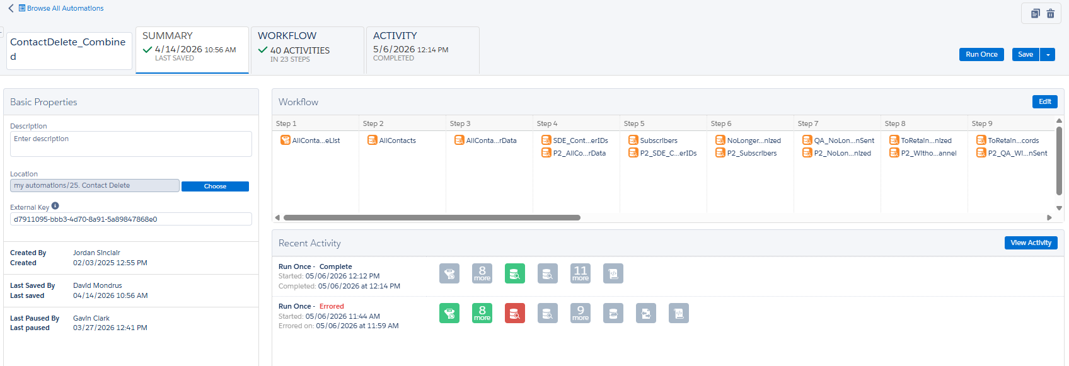
The current ContactDelete Combined Automation is a scheduled automation designed to delete stale contacts on a monthly basis. It appears to be a merge of two previous automations created Jan 2025. The DE Folders are messy and not always referencing the standard location. The Automation uses a filtered mobile list as its input source and has two separate streams and two separate deletes at the end. It doesn’t use the contacts without a channel DE, it simulates it using its own logic. Some descriptions are missing or incorrectly placed. And of course, it doesn’t have the auto suppression list functionality we need.

Recommended Pseudo Code
We should rebuild this automation from scratch because the current automation is no longer suitable for our use case. The automation should be built using the steps below as a guide. I also recommend we run this Automation weekly to minimize runtime while also maintaining good data hygiene and batching. Because this automation runs weekly and users expect signups to work immediately, a different process will need to remove users from the auto suppression list when they resubscribe in addition to this automation handling any stragglers.
Clear all working tables
Rebuild the exclusion list
Create a cache from _subscribers with counts
Backup all DE’s currently in the Duplicate Delete Data Archive automation
Collect Subid’s with more than 1 email (grab the oldest, leave 1 most recent)
Collect orphans from synchronized DE’s.
Users
Leads
Contacts
Collect Emails from “no channel”
Collect orphan emails from _subscribers that are active and have no SF ID
Collect emails that have not be sent to in 6 months
Collect emails from from _subscribers that are NOT active
Add not active emails to the auto suppression list if not already there.
Remove from the auto suppression list any emails that have become active since the last run.
Add all email to be deleted to the deletion archive with deletion date
Move the current archive to disk
Do the delete

Auto Suppression list management
SFMC allows for the creation and management of an autosuppresion list that automatically suppresses sends to emails enterprise wide. These lists are available via Email Studio/Admin/Auto Supression Configuration menus.
Once the auto suppression list is created, it functions as a DE allowing programmatic management via SSJS standard DE CRUD functionality.
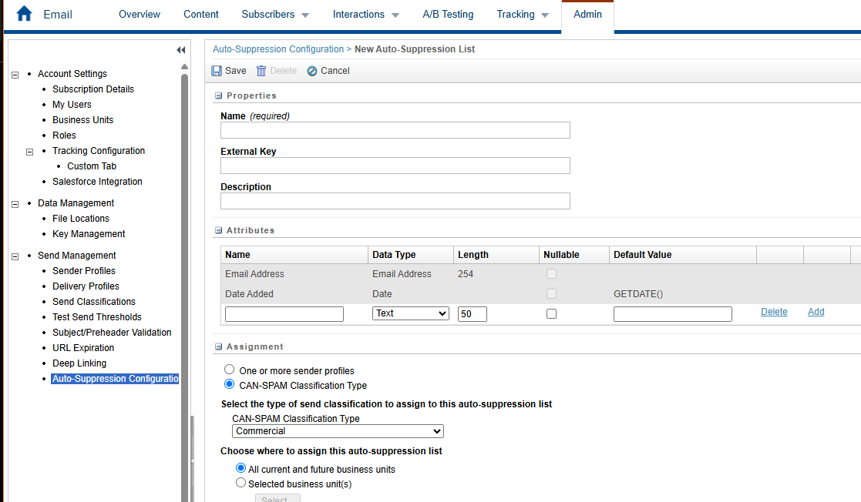
Example code for deleting multiple records from an auto suppression list.
<script runat="server">
Platform.Load("Core","1.1.1");
var deleteEmails = DataExtension.Init("toDelete");
var data = deleteEmails.Rows.Retrieve();
for (var i=0; i < data.length; i++) {
var email = data[i].Email;
var deleteRow = Platform.Function.DeleteData('AutoSuppressionExternalKey',['Email Address'],[email]);
};
</script>

Set 1
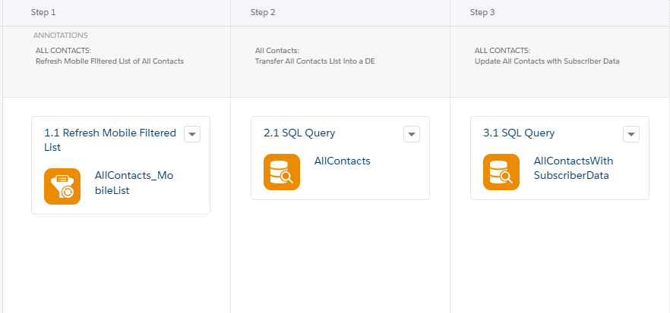
This set refreshes the All Contacts Mobile Filtered list, gets the SubscriberKey from that list and then creates a cache DE with joins in _subscribers and _BusinessUnitUnsubscribes.
Step 2.1
SELECT
SubscriberKey AS ContactKey
FROM [AllContacts_MobileList]

Step 3.1
SELECT
c.ContactKey,
s.EmailAddress,
s.Status,
s.DateJoined,
s.DateUnsubscribed,
s.DateUndeliverable,
s.BounceCount,
s.SubscriberType,
buu.BusinessUnitID AS BUUnsub_BusinessUnitID,
buu.UnsubReason AS BUUnsub_UnsubReason
FROM [AllContacts] AS c
LEFT JOIN [_Subscribers] AS s
ON c.ContactKey = s.SubscriberKey
LEFT JOIN [_BusinessUnitUnsubscribes] AS buu
ON c.ContactKey = buu.SubscriberKey

Set 2

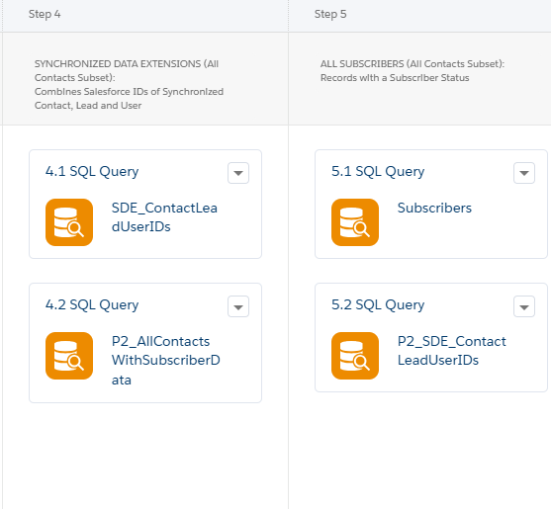
This set concatenates all the Contacts/Users/Leads, enriches the allcontacts cache with _subscriber data, grabs all subscribers that have no status (never been mailed) and concatenate all the Contacts/Users/Leads on path 2.
Step 4.1
SELECT
c.Id,
s.EmailAddress,
s.Status,
s.DateJoined,
s.DateUnsubscribed,
s.DateUndeliverable,
s.BounceCount,
s.SubscriberType
FROM [Contact_Salesforce_5] AS c
LEFT JOIN AllContactsWithSubscriberData AS s
ON c.Id = s.ContactKey
UNION
SELECT
l.Id,
s.EmailAddress,
s.Status,
s.DateJoined,
s.DateUnsubscribed,
s.DateUndeliverable,
s.BounceCount,
s.SubscriberType
FROM [Lead_Salesforce_5] AS l
LEFT JOIN AllContactsWithSubscriberData AS s
ON l.Id = s.ContactKey
UNION
SELECT
u.Id,
s.EmailAddress,
s.Status,
s.DateJoined,
s.DateUnsubscribed,
s.DateUndeliverable,
s.BounceCount,
s.SubscriberType
FROM [User_Salesforce_5] AS u
LEFT JOIN AllContactsWithSubscriberData AS s
ON u.Id = s.ContactKey
Step 4.2
SELECT
c.ContactKey,
s.EmailAddress,
s.Status,
s.DateJoined,
s.DateUnsubscribed,
s.DateUndeliverable,
s.BounceCount,
s.SubscriberType
FROM AllContacts AS c
LEFT JOIN _Subscribers AS s
ON c.ContactKey = s.SubscriberKey
Step 5.1
SELECT
ContactKey AS SubscriberKey,
EmailAddress,
Status,
DateJoined,
DateUnsubscribed,
DateUndeliverable,
BounceCount,
SubscriberType
FROM AllContactsWithSubscriberData
WHERE Status IS NOT NULL
Step 5.2
SELECT
c.Id,
c.Email AS EmailAddress
FROM [Contact_Salesforce_5] AS c
UNION
SELECT
l.Id,
l.Email AS EmailAddress
FROM [Lead_Salesforce_5] AS l
UNION
SELECT
u.Id,
u.Email AS EmailAddress
FROM [User_Salesforce_5] AS u

Set 3
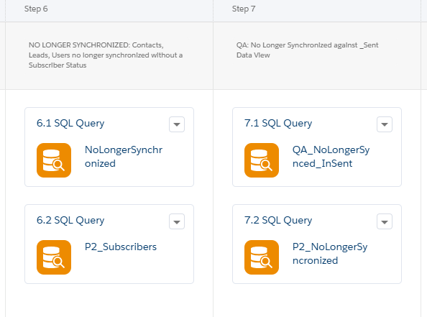
This set combines user/leads/contacts orphans for path 1 and path 2, pulls subscribers into a cache for Path 2 and creates a DE of orphans who have been sent to in the last 6 months.
Step 6.1

SELECT
c.ContactKey,
c.EmailAddress,
c.Status,
c.DateJoined,
c.DateUnsubscribed,
c.DateUndeliverable,
c.BounceCount,
c.SubscriberType
FROM AllContactsWithSubscriberData AS c
LEFT JOIN [Lead_Salesforce_5] AS sl
ON c.ContactKey = sl.ID
LEFT JOIN [Contact_Salesforce_5] AS sc
ON c.ContactKey = sc.ID
LEFT JOIN [User_Salesforce_5] AS su
ON c.ContactKey = su.ID
WHERE
((
c.ContactKey LIKE '003%'
AND sc.ID IS NULL
)
OR
(
c.ContactKey LIKE '00Q%'
AND sl.ID IS NULL
)
OR
(
c.ContactKey LIKE '005%'
AND su.ID IS NULL
))
AND
c.Status IS NULL
Step 6.2
SELECT
s.SubscriberKey,
s.EmailAddress,
s.Status,
s.DateJoined,
s.DateUnsubscribed,
s.DateUndeliverable,
s.BounceCount,
s.SubscriberType
FROM _Subscribers AS s
Step 7.1
SELECT
c.ContactKey,
s.EventDate
FROM NoLongerSynchronized AS c
INNER JOIN _Sent AS s
ON c.ContactKey = s.SubscriberKey
Step 7.2
SELECT
c.ContactKey,
c.EmailAddress,
c.Status,
c.DateJoined,
c.DateUnsubscribed,
c.DateUndeliverable,
c.BounceCount,
c.SubscriberType
FROM P2_AllContactsWithSubscriberData AS c
LEFT JOIN [Lead_Salesforce_5] AS sl
ON c.ContactKey = sl.ID
LEFT JOIN [Contact_Salesforce_5] AS sc
ON c.ContactKey = sc.ID
LEFT JOIN [User_Salesforce_5] AS su
ON c.ContactKey = su.ID
WHERE
((
c.ContactKey LIKE '003%'
AND sc.ID IS NULL
)
OR
(
c.ContactKey LIKE '00Q%'
AND sl.ID IS NULL
)
OR
(
c.ContactKey LIKE '005%'
AND su.ID IS NULL
))
AND
c.Status IS NULL

Set 4
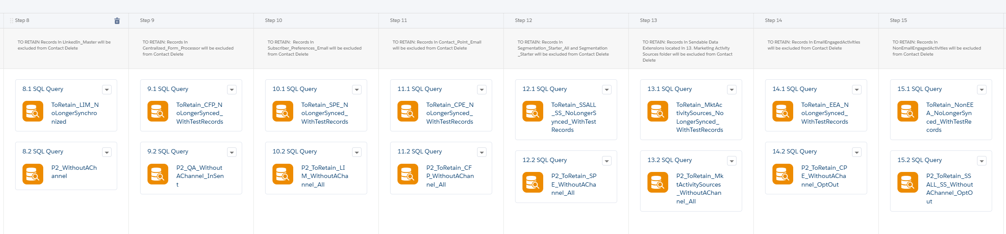
This set collects ContactKeys for orphan records that are to be retained and not deleted. It collects that information from the following DE’s in both Path 1 and Path 2:
LinkedIn Master
Central Form Processor
Subscriber Preferences Email
Contact Point Email
Segmentation Starter/Segmentation Starter ALL
Combined Followup
Intrado Master Segmentation
Intrado Master Segmentation Automation
Intrado Master Segmentation Segmentation Record Keeper
LinkedIn Initiative US Master
LinkedIn Master Temp
MIPA 15 Day
MIPA 5 Day
Tax Benchmarking Survey Completed Master Update with Business Days
Vendor Contact Data K Central Master
Web RFP Global Master
Web RFP Global Master Update Comment Field
MIPA Qualified Records 3
MIPA Qualified Records 2
MIPA Pre Qualified Records
Email Engaged Activities
NON Email Engaged Activities

Step 8.1
SELECT
c.ContactKey,
lim.SalesforceID,
lim.EmailAddress,
lim.FormName,
lim.DateProcessed,
lim.LeadSource
FROM NoLongerSynchronized AS c
INNER JOIN LinkedIn_Master AS lim
ON c.ContactKey = lim.SalesforceID
Step 8.2
SELECT
c.ContactKey,
c.EmailAddress,
c.Status,
c.DateJoined,
c.DateUnsubscribed,
c.DateUndeliverable,
c.BounceCount,
c.SubscriberType
FROM P2_AllContactsWithSubscriberData AS c
WHERE c.ContactKey NOT IN (
SELECT ContactKey FROM P2_NoLongerSynchronized
UNION ALL
SELECT Id AS ContactKey FROM P2_SDE_ContactLeadUserIDs
UNION ALL
SELECT SubscriberKey AS ContactKey FROM _Subscribers
UNION ALL
SELECT EmailAddress AS ContactKey FROM _Subscribers
UNION ALL
SELECT SalesforceID AS ContactKey FROM SyncedSalesforceIDs_H3QA
)
Step 9.1
SELECT
c.ContactKey,
cfp.Salesforce_ID,
cfp.EmailAddress,
cfp.formName,
cfp.Date,
cfp.Lead_Source_Detail,
cfp.Inquiry_Type
FROM NoLongerSynchronized AS c
INNER JOIN Centralized_Form_Processor_DE as cfp
ON c.ContactKey = cfp.Salesforce_ID
Step 9.2
SELECT
wac.ContactKey,
wac.EmailAddress,
s.EventDate
FROM P2_WithoutAChannel AS wac
INNER JOIN _Sent AS s
ON wac.ContactKey = s.SubscriberKey

UNION

SELECT
wac.ContactKey,
wac.EmailAddress,
s.EventDate
FROM P2_WithoutAChannel AS wac
INNER JOIN _Sent AS s
ON wac.EmailAddress = s.SubscriberKey
Step 10.1
SELECT
c.ContactKey,
spe.Salesforce_ID,
spe.EmailAddress,
spe.Date AS SPEDate,
spe.Initiated_By
FROM NoLongerSynchronized AS c
INNER JOIN Subscriber_Preferences_Email as spe
ON c.ContactKey = spe.Salesforce_ID

Step 10.2
SELECT
c.ContactKey,
lim.SalesforceID,
lim.EmailAddress,
lim.FormName,
lim.DateProcessed,
lim.LeadSource
FROM P2_WithoutAChannel AS c
INNER JOIN LinkedIn_Master AS lim
ON c.ContactKey = lim.EmailAddress
Step 11.1
SELECT
c.ContactKey,
cpe.KPMG_Lead_Contact_Id__c,
cpe.EmailAddress,
cpe.IsDeleted,
cpe.IsPrimary,
cpe.CreatedDate,
cpe.LastModifiedDate
FROM NoLongerSynchronized AS c
INNER JOIN [ContactPointEmail_Salesforce_5] AS cpe
ON c.ContactKey = cpe.KPMG_Lead_Contact_Id__c
Step 11.2
SELECT
c.ContactKey,
cfp.Salesforce_ID,
cfp.EmailAddress,
cfp.formName,
cfp.Date,
cfp.Lead_Source_Detail,
cfp.Inquiry_Type
FROM P2_WithoutAChannel AS c
INNER JOIN Centralized_Form_Processor_DE as cfp
ON c.ContactKey = cfp.EmailAddress
Step 12.1
SELECT
c.ContactKey,
cpe.KPMG_Lead_Contact_Id__c,
ssa.Salesforce_ID,
ssa.EmailAddress,
ssa.IsPrimary_Email,
ssa.OptOut_Status_E,
ssa.IsActive
FROM NoLongerSynchronized AS c
LEFT JOIN [ContactPointEmail_Salesforce_5] AS cpe
ON c.ContactKey = cpe.KPMG_Lead_Contact_Id__c
INNER JOIN Segmentation_Starter_ALL AS ssa
ON cpe.EmailAddress = ssa.EmailAddress

UNION

SELECT
c.ContactKey,
cpe.KPMG_Lead_Contact_Id__c,
ss.Salesforce_ID,
ss.EmailAddress,
ss.IsPrimary_Email,
ss.OptOut_Status_E,
ss.IsActive
FROM NoLongerSynchronized AS c
LEFT JOIN [ContactPointEmail_Salesforce_5] AS cpe
ON c.ContactKey = cpe.KPMG_Lead_Contact_Id__c
INNER JOIN Segmentation_Starter AS ss
ON cpe.EmailAddress = ss.EmailAddress
Step 12.2
SELECT
c.ContactKey,
spe.Salesforce_ID,
spe.EmailAddress,
spe.Date AS SPEDate,
spe.Initiated_By
FROM P2_WithoutAChannel AS c
INNER JOIN Subscriber_Preferences_Email as spe
ON c.ContactKey = spe.EmailAddress

Step 13.1

SELECT
c.ContactKey,
cf.SalesforceID,
cf.EmailAddress
FROM NoLongerSynchronized AS c
INNER JOIN Combined_Followup AS cf
ON c.ContactKey = cf.SalesforceID

UNION

SELECT
c.ContactKey,
im.SalesforceID,
im.EmailAddress
FROM NoLongerSynchronized AS c
INNER JOIN Intrado_MASTER_segmetation AS im
ON c.ContactKey = im.SalesforceID

UNION

SELECT
c.ContactKey,
ima.SalesforceID,
ima.EmailAddress
FROM NoLongerSynchronized AS c
INNER JOIN Intrado_MASTER_segmetation_Automation AS ima
ON c.ContactKey = ima.SalesforceID

UNION

SELECT
c.ContactKey,
irk.SalesforceID,
irk.EmailAddress
FROM NoLongerSynchronized AS c
INNER JOIN Intrado_MASTER_segmetation_Record_Keeper AS irk
ON c.ContactKey = irk.SalesforceID

UNION

SELECT
c.ContactKey,
liu.SalesforceID,
liu.Workemail AS EmailAddress
FROM NoLongerSynchronized AS c
INNER JOIN LinkedIn_Initiative_US_Master AS liu
ON c.ContactKey = liu.SalesforceID

UNION

SELECT
c.ContactKey,
lmt.SalesforceID,
lmt.EmailAddress
FROM NoLongerSynchronized AS c
INNER JOIN LinkedIn_Master_Temp AS lmt
ON c.ContactKey = lmt.SalesforceID

UNION

SELECT
c.ContactKey,
m15.SalesforceID,
m15.EmailAddress
FROM NoLongerSynchronized AS c
INNER JOIN MIPA_15Day AS m15
ON c.ContactKey = m15.SalesforceID

UNION

SELECT
c.ContactKey,
m5.SalesforceID,
m5.EmailAddress
FROM NoLongerSynchronized AS c
INNER JOIN MIPA_5Day AS m5
ON c.ContactKey = m5.SalesforceID

UNION

SELECT
c.ContactKey,
tsc.SalesforceID,
tsc.EmailAddress
FROM NoLongerSynchronized AS c
INNER JOIN TaxbenchmarkingSurveyCompleted_MASTER_UpdateWith_BusinessDays AS tsc
ON c.ContactKey = tsc.SalesforceID

UNION

SELECT
c.ContactKey,
vcdk.SalesforceID,
vcdk.EmailAddress
FROM NoLongerSynchronized AS c
INNER JOIN VendorContactDataKcentral_MASTER AS vcdk
ON c.ContactKey = vcdk.SalesforceID

UNION

SELECT
c.ContactKey,
wrg.SalesforceID,
wrg.EmailAddress
FROM NoLongerSynchronized AS c
INNER JOIN WebRFPGlobal_MASTER AS wrg
ON c.ContactKey = wrg.SalesforceID

UNION

SELECT
c.ContactKey,
wrgu.SalesforceID,
wrgu.EmailAddress
FROM NoLongerSynchronized AS c
INNER JOIN WebRFPGlobal_Master_Update_Comment_Field AS wrgu
ON c.ContactKey = wrgu.SalesforceID

UNION

SELECT
c.ContactKey,
m3.SalesforceID,
m3.EmailAddress
FROM NoLongerSynchronized AS c
INNER JOIN MIPA_QualifiedRecords3 AS m3
ON c.ContactKey = m3.SalesforceID

UNION

SELECT
c.ContactKey,
m2.SalesforceID,
m2.EmailAddress
FROM NoLongerSynchronized AS c
INNER JOIN MIPA_QualifiedRecords2 AS m2
ON c.ContactKey = m2.SalesforceID

UNION

SELECT
c.ContactKey,
mpqr.SalesforceID,
mpqr.EmailAddress
FROM NoLongerSynchronized AS c
INNER JOIN MIPA_PreQualifiedRecords AS mpqr
ON c.ContactKey = mpqr.SalesforceID

Step 13.2

SELECT
c.ContactKey,
cf.SalesforceID,
cf.EmailAddress
FROM P2_WithoutAChannel AS c
INNER JOIN Combined_Followup AS cf
ON c.ContactKey = cf.EmailAddress

UNION

SELECT
c.ContactKey,
im.SalesforceID,
im.EmailAddress
FROM P2_WithoutAChannel AS c
INNER JOIN Intrado_MASTER_segmetation AS im
ON c.ContactKey = im.EmailAddress

UNION

SELECT
c.ContactKey,
ima.SalesforceID,
ima.EmailAddress
FROM P2_WithoutAChannel AS c
INNER JOIN Intrado_MASTER_segmetation_Automation AS ima
ON c.ContactKey = ima.EmailAddress

UNION

SELECT
c.ContactKey,
irk.SalesforceID,
irk.EmailAddress
FROM P2_WithoutAChannel AS c
INNER JOIN Intrado_MASTER_segmetation_Record_Keeper AS irk
ON c.ContactKey = irk.EmailAddress

UNION

SELECT
c.ContactKey,
liu.SalesforceID,
liu.Workemail AS EmailAddress
FROM P2_WithoutAChannel AS c
INNER JOIN LinkedIn_Initiative_US_Master AS liu
ON c.ContactKey = liu.Workemail

UNION

SELECT
c.ContactKey,
lmt.SalesforceID,
lmt.EmailAddress
FROM P2_WithoutAChannel AS c
INNER JOIN LinkedIn_Master_Temp AS lmt
ON c.ContactKey = lmt.EmailAddress

UNION

SELECT
c.ContactKey,
m15.SalesforceID,
m15.EmailAddress
FROM P2_WithoutAChannel AS c
INNER JOIN MIPA_15Day AS m15
ON c.ContactKey = m15.EmailAddress

UNION

SELECT
c.ContactKey,
m5.SalesforceID,
m5.EmailAddress
FROM P2_WithoutAChannel AS c
INNER JOIN MIPA_5Day AS m5
ON c.ContactKey = m5.EmailAddress

UNION

SELECT
c.ContactKey,
tsc.SalesforceID,
tsc.EmailAddress
FROM P2_WithoutAChannel AS c
INNER JOIN TaxbenchmarkingSurveyCompleted_MASTER_UpdateWith_BusinessDays AS tsc
ON c.ContactKey = tsc.EmailAddress

UNION

SELECT
c.ContactKey,
vcdk.SalesforceID,
vcdk.EmailAddress
FROM P2_WithoutAChannel AS c
INNER JOIN VendorContactDataKcentral_MASTER AS vcdk
ON c.ContactKey = vcdk.EmailAddress

UNION

SELECT
c.ContactKey,
wrg.SalesforceID,
wrg.EmailAddress
FROM P2_WithoutAChannel AS c
INNER JOIN WebRFPGlobal_MASTER AS wrg
ON c.ContactKey = wrg.EmailAddress

UNION

SELECT
c.ContactKey,
wrgu.SalesforceID,
wrgu.EmailAddress
FROM P2_WithoutAChannel AS c
INNER JOIN WebRFPGlobal_Master_Update_Comment_Field AS wrgu
ON c.ContactKey = wrgu.EmailAddress

UNION

SELECT
c.ContactKey,
m3.SalesforceID,
m3.EmailAddress
FROM P2_WithoutAChannel AS c
INNER JOIN MIPA_QualifiedRecords3 AS m3
ON c.ContactKey = m3.EmailAddress

UNION

SELECT
c.ContactKey,
m2.SalesforceID,
m2.EmailAddress
FROM P2_WithoutAChannel AS c
INNER JOIN MIPA_QualifiedRecords2 AS m2
ON c.ContactKey = m2.EmailAddress

UNION

SELECT
c.ContactKey,
mpqr.SalesforceID,
mpqr.EmailAddress
FROM P2_WithoutAChannel AS c
INNER JOIN MIPA_PreQualifiedRecords AS mpqr
ON c.ContactKey = mpqr.EmailAddress

Step 14.1
SELECT
c.ContactKey,
eea.EmailAddress,
cpe.EmailAddress AS CPEEmailAddress
FROM NoLongerSynchronized AS c
LEFT JOIN [ContactPointEmail_Salesforce_5] AS cpe
ON c.ContactKey = cpe.KPMG_Lead_Contact_Id__c
INNER JOIN (SELECT DISTINCT SalesforceID, EmailAddress
FROM EmailEngagedActivities) AS eea
ON eea.SalesforceID = c.ContactKey
Step 14.2
SELECT

ifd.KPMG_ContactID__c
,ifd.KPMG_Consent_Status__c as OptOut_Status_E
,ifd.KPMG_Alumni_Opt_in__c as OptIn

,p2.ContactKey

, cpe.KPMG_Lead_Contact_Id__c
, cpe.EmailAddress
, cpe.IsDeleted
, cpe.IsPrimary
, cpe.CreatedDate
, cpe.LastModifiedDate

FROM P2_WithoutAChannel p2

left JOIN ContactPointEmail_Salesforce_5 cpe
ON p2.ContactKey = cpe.EmailAddress

Left join KPMG_Individual_Firm_Details__c_Salesforce_3 ifd on ifd.KPMG_ContactId__c = cpe.KPMG_Lead_Contact_Id__c

WHERE
ifd.KPMG_Consent_Status__c = 'Opt Out'

Set 5
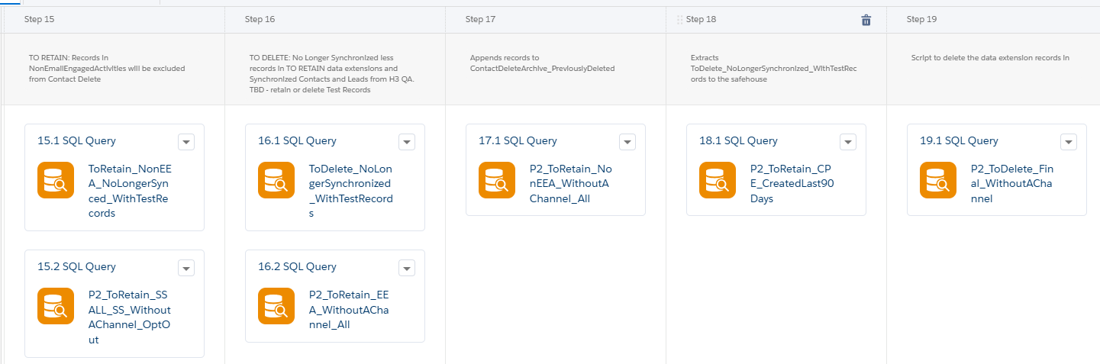
This set continues the retention work and create the P2 and P1 delete DE’s.

Step 15.1
SELECT
c.ContactKey,
neea.EmailAddress,
cpe.EmailAddress AS CPEEmailAddress
FROM NoLongerSynchronized AS c
LEFT JOIN [ContactPointEmail_Salesforce_5] AS cpe
ON c.ContactKey = cpe.KPMG_Lead_Contact_Id__c
INNER JOIN (SELECT DISTINCT SalesforceID, EmailAddress
FROM NonEmailEngagedActivities) AS neea
ON neea.SalesforceID = c.ContactKey
Step 15.2
SELECT
c.ContactKey,
ssa.Salesforce_ID,
ssa.EmailAddress,
ssa.IsPrimary_Email,
ifd.KPMG_Consent_Status__c as OptOut_Status_E,
ssa.IsActive
FROM P2_WithoutAChannel c
JOIN Segmentation_Starter_ALL ssa
ON c.ContactKey = ssa.EmailAddress
JOIN ContactPointEmail_Salesforce_5 cpe
ON ssa.EmailAddress = cpe.EmailAddress
join KPMG_Individual_Firm_Details__c_Salesforce_3 ifd on ifd.KPMG_ContactId__c = cpe.KPMG_Lead_Contact_Id__c
WHERE
ifd.KPMG_Consent_Status__c = 'Opt Out'
UNION
SELECT
c.ContactKey,
ss.Salesforce_ID,
ss.EmailAddress,
ss.IsPrimary_Email,
ifd.KPMG_Consent_Status__c as OptOut_Status_E,
ss.IsActive

FROM P2_WithoutAChannel c
JOIN Segmentation_Starter ss
ON c.ContactKey = ss.EmailAddress
JOIN ContactPointEmail_Salesforce_5 cpe
ON ss.EmailAddress = cpe.EmailAddress
join KPMG_Individual_Firm_Details__c_Salesforce_3 ifd on ifd.KPMG_ContactId__c = cpe.KPMG_Lead_Contact_Id__c
WHERE
ifd.KPMG_Consent_Status__c = 'Opt Out'
Step 16.1
SELECT
nls.ContactKey,
nls.EmailAddress,
nls.Status,
nls.DateJoined,
nls.DateUnsubscribed,
'NoLongerSynchornized' AS DeleteReason
FROM NoLongerSynchronized AS nls
WHERE nls.ContactKey NOT IN (
SELECT ContactKey FROM ToRetain_CFP_NoLongerSynced_WithTestRecords
UNION ALL
SELECT ContactKey FROM ToRetain_LIM_NoLongerSynced
UNION ALL
SELECT ContactKey FROM ToRetain_SPE_NoLongerSynced_WithTestRecords
UNION ALL
SELECT ContactKey FROM ToRetain_CPE_NoLongerSynced_WithTestRecords
UNION ALL
SELECT ContactKey FROM ToRetain_SSALL_SS_NoLongerSynced_WithTestRecords
UNION ALL
SELECT ContactKey FROM ToRetain_MktActivitySources_NoLongerSynced_WithTestRecords
UNION ALL
SELECT ContactKey FROM ToRetain_EEA_NoLongerSynced_WithTestRecords
UNION ALL
SELECT ContactKey FROM ToRetain_NonEEA_NoLongerSynced_WithTestRecords
UNION ALL
SELECT SalesforceID AS ContactKey FROM SyncedSalesforceIDs_H3QA
)
Step 16.2
SELECT
c. ContactKey,
eea.EmailAddress,
eea.SalesforceID
FROM P2_WithoutAChannel AS c
INNER JOIN EmailEngagedActivities AS eea
ON c.ContactKey = eea.EmailAddress
Step 17.1
SELECT
c. ContactKey,
neea.EmailAddress,
neea.SalesforceID
FROM P2_WithoutAChannel AS c
INNER JOIN NonEmailEngagedActivities AS neea
ON c.ContactKey = neea.EmailAddress
Step 18.1
SELECT
c.ContactKey,cpe.EmailAddress,cpe.KPMG_Lead_Contact_Id__c,
cpe.CreatedDate,
cpe.IsPrimary,
cpe.IsDeleted
FROM P2_WithoutAChannel AS c
INNER JOIN ContactPointEmail_Salesforce_5 AS cpe
ON c.ContactKey = cpe.EmailAddress
WHERE
cpe.CreatedDate >= DATEADD(day, -90, GETDATE())
Step 19.1
SELECT
wac.ContactKey,
wac.EmailAddress,
wac.Status,
wac.DateJoined,
wac.DateUnsubscribed,
wac.DateUndeliverable,
'WithoutAChannel' AS DeleteReason
FROM P2_WithoutAChannel AS wac
WHERE wac.ContactKey NOT IN (
SELECT ContactKey FROM P2_ToRetain_LIM_WithoutAChannel_All
UNION ALL
SELECT ContactKey FROM P2_ToRetain_CFP_WithoutAChannel_All
UNION ALL
SELECT ContactKey FROM P2_ToRetain_SPE_WithoutAChannel_All
UNION ALL
SELECT ContactKey FROM P2_ToRetain_CPE_WithoutAChannel_OptOut
UNION ALL
SELECT ContactKey FROM P2_ToRetain_SSALL_SS_WithoutAChannel_OptOut
UNION ALL
SELECT ContactKey FROM P2_ToRetain_MktActivitySources_WithoutAChannel_All
UNION ALL
SELECT ContactKey FROM P2_ToRetain_EEA_WithoutAChannel_All
UNION ALL
SELECT ContactKey FROM P2_ToRetain_NonEEA_WithoutAChannel_All
UNION ALL
SELECT SalesforceID AS ContactKey FROM SyncedSalesforceIDs_H3QA
UNION ALL
SELECT ContactKey FROM P2_ToRetain_CPE_CreatedLast90Days
)

Set 6
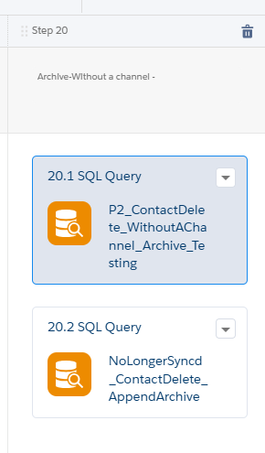

This set creates an archive of the data it’s about to delete.

Step 20.1
SELECT
ContactKey
,EmailAddress
,Status
,DateJoined
,DateUnsubscribed
,DeleteReason
, DeleteDate

From ToDelete_WithoutAChannel
Step 20.2
Select

ContactKey
,EmailAddress
,Status
,DateJoined
,DateUnsubscribed
,DeleteReason
,DeleteDate

From ToDelete_NoLongerSynchronized_WithTestRecords

Set 7
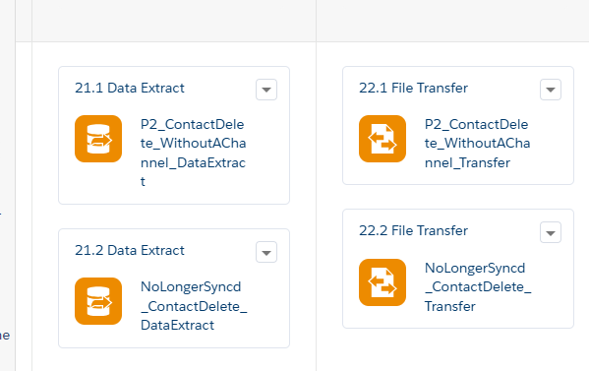
This set extracts the to be deleted data and move it to the FTP server.

Step 21.1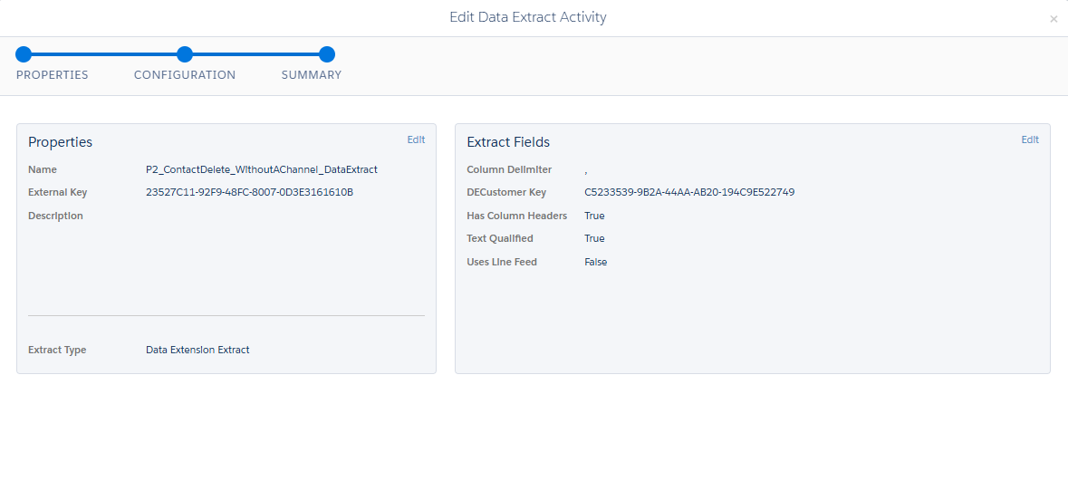
Step 21.2
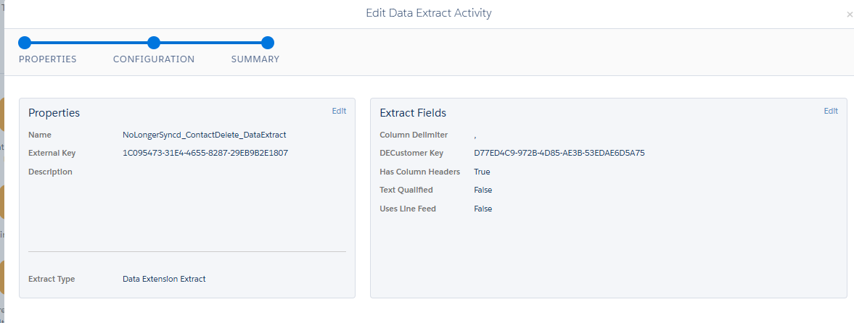
Step 22.1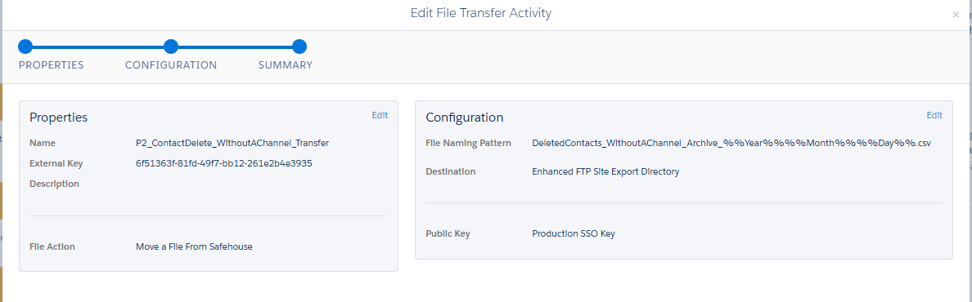
Step 22.2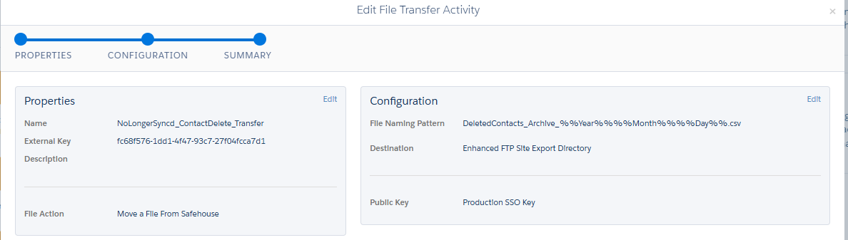

Set 8
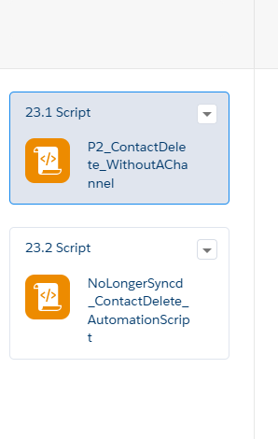
This set does the actual delete via SSJS Code
Step 23.1
<script runat="server">
Platform.Load("Core", "1");
//AUTHENTICATE

var url = "https://mchhklk0drvdbjf-g54n6vj27bky.auth.marketingcloudapis.com/v2/token";
var contentType = "application/json";
var payload = '{"grant_type": "client_credentials","client_id": "fop80b29y9dlpmklnxpcsx6l","client_secret": "3NZddX3ohf5D2YI2RBRL7roK","account_id":"514007235"}';
var accessTokenResult = HTTP.Post(url, contentType, payload);
var accessToken = Platform.Function.ParseJSON(accessTokenResult["Response"][0]).access_token;
if (accessToken != "") {
//EXECUTE
try {
var deleteUrl = "https://mchhklk0drvdbjf-g54n6vj27bky.rest.marketingcloudapis.com/contacts/v1/contacts/actions/delete?type=listReference";
var payload1 = '{"DeleteOperationType": "ContactAndAttributes","targetList": {"listType": {"listTypeID": 3},"listKey": "4FB47295-249A-45CB-802B-4CD6016B7F6A"},"deleteListWhenCompleted": false,"deleteListContentsWhenCompleted": true}';
var headerNames = ["Authorization"];
var s1 = "Bearer ";
var headerValues = [s1.concat(accessToken)];
var result = HTTP.Post(deleteUrl, contentType, payload1, headerNames, headerValues);

Write("Delete Result: " + Stringify(result));
} catch (ex) {
Write("Exception Error: " + Stringify(ex));
}
}
</script>
Step 23.2
<script runat="server">
Platform.Load("Core", "1");
//AUTHENTICATE

var url = "https://mchhklk0drvdbjf-g54n6vj27bky.auth.marketingcloudapis.com/v2/token";
var contentType = "application/json";
var payload = '{"grant_type": "client_credentials","client_id": "fop80b29y9dlpmklnxpcsx6l","client_secret": "3NZddX3ohf5D2YI2RBRL7roK","account_id":"514007235"}';
var accessTokenResult = HTTP.Post(url, contentType, payload);
var accessToken = Platform.Function.ParseJSON(accessTokenResult["Response"][0]).access_token;
if (accessToken != "") {
//EXECUTE
try {
var deleteUrl = "https://mchhklk0drvdbjf-g54n6vj27bky.rest.marketingcloudapis.com/contacts/v1/contacts/actions/delete?type=listReference";
var payload1 = '{"DeleteOperationType": "ContactAndAttributes","targetList": {"listType": {"listTypeID": 3},"listKey": "D77ED4C9-972B-4D85-AE3B-53EDAE6D5A75"},"deleteListWhenCompleted": false,"deleteListContentsWhenCompleted": true}';
var headerNames = ["Authorization"];
var s1 = "Bearer ";
var headerValues = [s1.concat(accessToken)];
var result = HTTP.Post(deleteUrl, contentType, payload1, headerNames, headerValues);

Write("Delete Result: " + Stringify(result));
} catch (ex) {
Write("Exception Error: " + Stringify(ex));
}
}
</script>

https://help.salesforce.com/s/articleView?id=000380704&type=1

